

**Some changes:**

**Token Name : AfricaCoin**

**Token Symbol : AFCO**

**Total Supply : 1000000000000000**

**Token Price : 0,00000000233**

**Token Decimals :8**

**Africacoin TOKEN** ($AFCO)

$AFCO is an autonomous frictionless yield farming and liquidity generation protocol. Simply hold $AFCO tokens in your wallet and you will get more $AFCO & $BNB

$AFCO is a community driven DeFi project built on Binance Smart Chain #BSC. $AFCO brings a revolutionary mechanism to BSC ecosystem: **Earn $BNB just by holding $AFCO token**

It does this by applying a 10% tax on transactions:

# 4% goes to BNB Reward Pool

* **4% goes to liquidity**

# 2% is distributed among the holders

**25% of the total supply will be burn after launch and sent it to a black hole address; as this address also participates in the protocol, it accumulates more tokens, thereby effectively removing them from circulation. There is no limit to the burn, the black hole will keep growing.**

# TOKENOMICS

Total Supply: 111B $AFCO

* + 66.4% for the Presale & Launch. 100% LP Locked for 6 Months
  + 5% for airdrop (Locked till Distribution)
  + Team only gets 1% which is locked, and 4% for marketing.
  + 3.6% will be allocated to community voted Projects.
  + Burnt rest of 20% of the foundation.

# Features

**Simplest Way to Earn $BNB**

**4%** of every transaction is taken and re-distributed to all $AFCO holders in $BNB.

You will have to wait for a specific duration called **cycle** (**Daily**) to collect your BNB reward.

In this waiting duration, if you continue to add more than 25% (**threshHoldTopUpRate**) of your $AFCO balance, the waiting duration will proportionally add up with the cycle.

*(If you sell $HOLD it does not affect your cycle)*

For example, on the first day of your cycle, you add up more 30% $AFCO, you have to wait:

**30%*1 days = 7.2** hours more. That means you can collect BNB after **1 days and 7.2 hours.**

But if the **threshAfcoTopUpRate >= 100%,** the waiting duration will add up max to 1 days

i.e **2 days.**

For example, on the first day of your cycle, you add up more 100% $AFCO, you have to wait:

**1 days** more. That means you can collect BNB after **2 days.**

This will prevent cheaters who try to add more **$AFCO** at the end of each cycle.

# Charities BNB Tax

If after rolling out the first testnet, we recognize that top $AFCO holders have more advantages when collecting BNB than others. Following the philosophy of building a pure community-driven project. We introduce a new tax feature.

If you collect more than **1 BNB**, **20%** of it will be used to donate to **charities.** This feature helps us contribute to noble causes !

Charity Wallet Address: …..

# Transaction Collection

With $AFCO, each transaction (buy/sell or wallet transfer) has a 10% Transaction Collection Fee where:

* **4%** of every transaction contributes toward automatically generating further liquidity on Pancake Swap. Benefiting long term for $AFCO holders the most!
* **4%** of every transaction is taken and re-distributed to all #HODL holders in **$BNB.**
* **2%** of every transaction is taken and re-distributed to all $AFCO holders. The burn address is also a holder thus each transaction helps deflate the supply.

# Automatic LP & RFI Static Rewards Automatic LP

As mentioned, there is a 10% tax on each transaction, 4% gets added to the liquidity on PancakeSwap through the contract.

This liquidity becomes locked away and inaccessible, once again raising the price floor each and every time a transaction is made.

# RFI- Static Rewards

2% of every transaction is taken and re-distributed to all $AFCO holders. The burn address is also a holder thus each transaction helps deflate the supply.

# Anti Whales

Along with the auto-generating liquidity protocol, we have added an Anti-Whale feature.

We have seen many $AFCO holders suffered the big dumps from the whales. For eg: NCAT price dropped 4 times in just hours because a whale dumped and took nearly **500 BNB** from the pool (and SAFEMOON case was **1771 BNB).**

So transactions (sell/buy and wallet transfer) that **trade** more than **0.1%** of the total supply will be rejected. This will protect price movement as well. The transaction though can be carried out through our dAPP feature of disruptive transfers.

# Disruptive Transfers

**Since the** transactions (sell/buy and wallet transfer) that **trade** more than **0.1%** of the total supply will be rejected. We developed a feature on our dAPP feature of disruptive transfers.

# Reference Image Below:

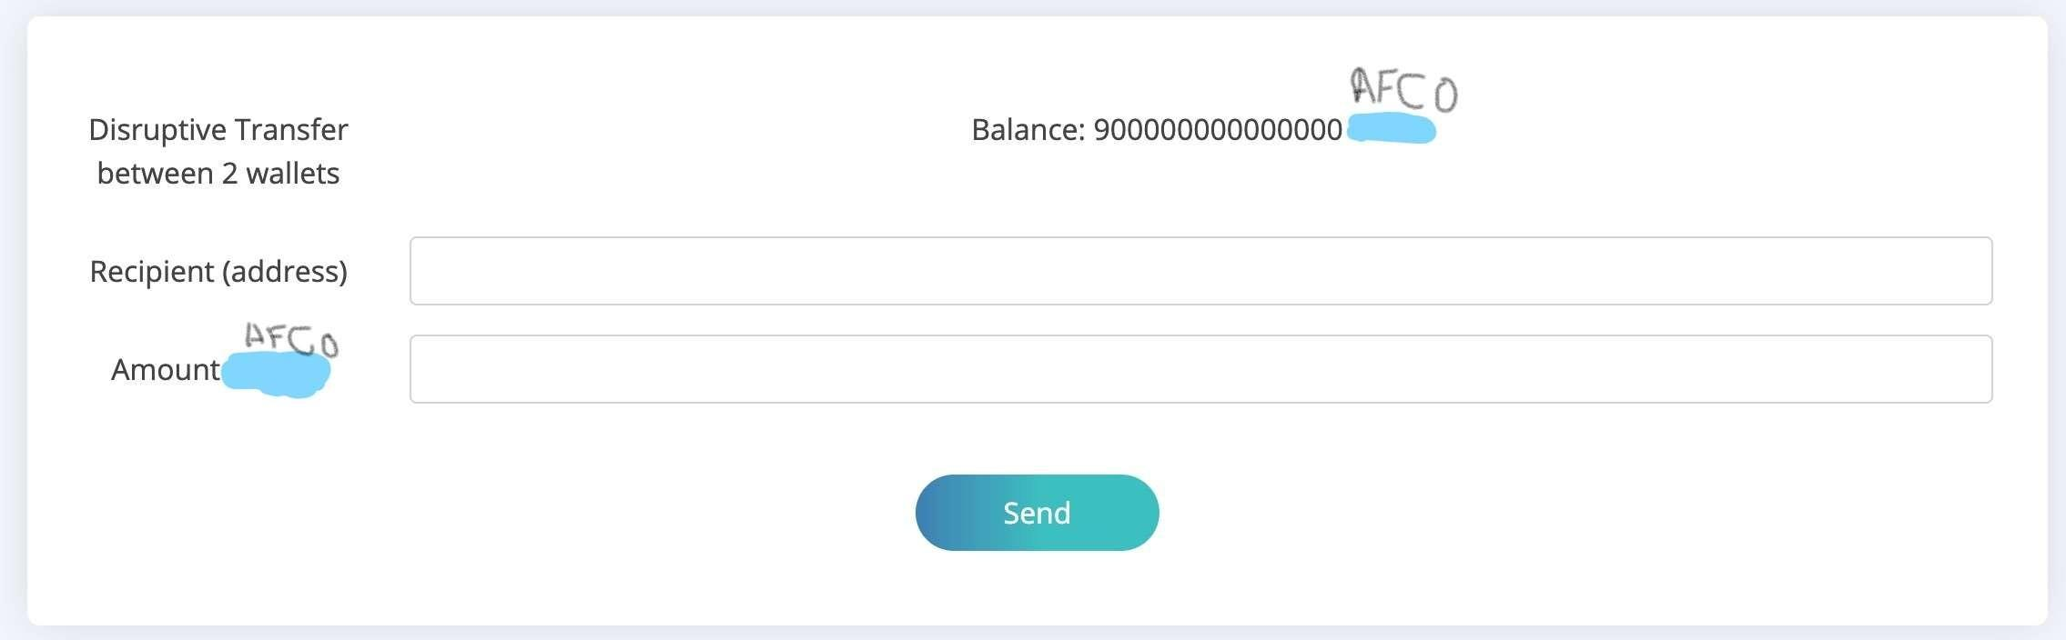

**What is Zero Balance?**

When you sell **all of your $AFCO** and your **balance = 0.**

Then you continue to buy $AFCO again. Your next collectable date will be extended **over 50 years.**

*Good luck and your children can collect your BNB for you!*

# What should I do?

If you still want to collect BNB, you can transfer your $AFCO to another wallet. Then you can collect your BNB normally **without waiting for over 50 years.**

Remember you will be charged 10% when transfer between wallet.

Furthermore, whales who make a **transfer (between 2 wallets)** that is larger than 1% of the total supply will be charged for 1 **BNB.** These BNBs go straight to the BNB reward pool in the Earn BNB feature.

# Charities Collection Charities BNB Collection

After rolling out the first testnet, we recognize that top $AFCO holders have more advantages when collecting BNB than others. Following the philosophy of building a pure community- driven project. We introduce a new charities feature.

If you collect more than **1 BNB**, **20%** of it will be used to donate to **charities.** This feature helps us contribute to noble causes!

Charity Wallet Address: …..